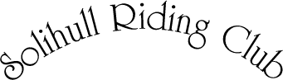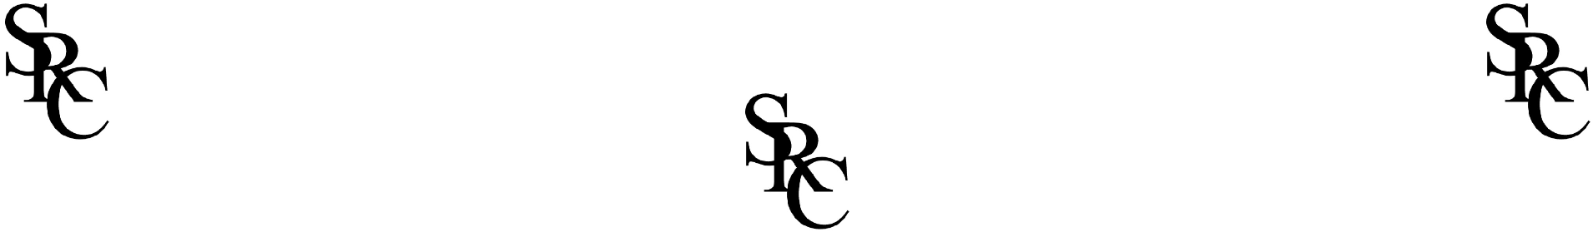

Code of Conduct
Club Officials
Solihull Riding Club seeks to promote a Club environment which users find pleasant, safe and enjoyable to use, and in which all users can achieve their personal and collective goals. Team Managers, Team Trainers and Other Club Officials are therefore expected to adhere to the following guidelines:
- Consider the wellbeing and safety of participants before the development of performance.
- Develop an appropriate working relationship with club officials, members and participants, based on mutual trust and respect.
- Make sure all activities are appropriate to the age, ability and experience of those taking part.
- Promote the positive aspects of the sport (e.g. fair play, responsibility for animals and their welfare- see BRC guidance on welfare standards here).
- Display consistently high standards of behaviour and appearance.
- Follow all guidelines laid down by the national governing body and the Club.
- Hold appropriate valid qualifications and insurance cover.
- Never exert undue influence over performers to obtain personal benefit or reward.
- Never condone rule violations, rough play or use of prohibited substances.
- Encourage participants to value their performances and not just results.
- Encourage and guide participants to accept responsibility for their own performance and behaviour.
- Treat all Club equipment and facilities with respect and use equipment and facilities in an appropriate manner (as defined in instructions and notices).
- Ensure safety regulations relating to facilities and individual activities are observed at all times.
- Ensure participants wear appropriate equipment and dress for the activities being undertaken (see G22: BRC Handbook https://www.bhs.org.uk/media/g1gf4mpd/brc-handbook-2023-final.pdf )
- Should not at any competition, training session or event, argue, behave with incivility or contempt, or use abusive or threatening language, towards another club official, judge, competition official or participant.
- Ensure no discrimination on the grounds of race, colour, religion or belief, disability, sex, marital status, age, sexual orientation, nationality and ethnic or national origins.

Safeguarding
- Solihull Riding Club as a British Riding Club is a Member Body of the British Equestrian Federation (BEF), and adheres to the BHS Policy on safeguarding, details of which can be found at www.bhs.org. uk/safeguardingchildren
- Solihull Riding Club reserve the right to restrict or prohibit attendance at any of its events to anyone who SRC considers to be an unsuitable person. Please reference the BRC policy on unsuitable persons for detail http://www.bhs.org.uk/safeguardingchildren
- For Junior participation, it is the team manager’s responsibility to gain parental consent for juniors to participate in SRC junior members training and events
Disciplinary Procedures
Club Officials are required to conduct themselves in a manner consistent with the above Code of Conduct. Where users breach this general requirement, the Committee will manage the disciplinary matters. Repeat breaches of the Code of Conduct may lead to suspension or expulsion.
Club Official Agreement to abide by this Code
I confirm that I have read and understand this Club Official Code of Conduct document:
Signed ............................................................ Date ................................................
Signatory Print Name......................................................
This agreement reflects the hopes and intentions of the Club Official agreeing to take on their designated role.
Please print and sign two copies of this code, one to be retained by the signatory the other to be held by the Club Secretary/Chair.

